The Legacy of Aunt Ester and 1839 Wylie
By Shana Laski, Dramaturg

Radio Golf’s Harmond and Roosevelt intend to redevelop a plot of land in the Hill District that requires the demolition of a house at 1839 Wylie Avenue. The two are surprised by the vehement resistance from several community members, which plants a kernel of hesitation that launches this play into motion. Reverently referred to as “Aunt Ester’s House,” the meaning this property holds to Elder Barlow and Sterling is palpable. Though each have a personal connection to the home, its importance is much larger than any of the characters could ever know.

August Wilson’s 10-play American Century Cycle contains a second, smaller cycle within it illustrating the life, impact, and legacy of Aunt Ester over the course of the larger Cycle’s 100-year span. It wasn’t until Gem of the Ocean, the second to last play, was written that her full backstory was fleshed out onstage. Before then, she was always an offstage presence that provided healing, history, and guidance for the Black community of the Hill District. Her age and her strong connection to her roots made her a living evocation of the history of Black America, from her birth in 1619 (the year the first African slave was shipped to America), to her death in 1985.

Gem of the Ocean, set in 1904, centers Aunt Ester and her red-doored home as a place where those in crisis come to seek her guidance. This was the case with Citizen Barlow, who came up from Alabama in search of freedom and to “get right with himself” after killing a man. Aunt Ester spiritually guides him to the City of Bones, where he can connect with his roots, atone for his sins, and come to terms with post-Civil War American reality. Her home serves as a refuge to those looking for support and community in the face of oppression and trauma.

She is mentioned again in Two Trains Running as a source of peace for troubled locals in the 1960s. Though she is never seen, she is described as a calming force who lays her hands upon the heads of those who seek her guidance and follow her instruction, soothing their weary souls. She gives permission to the men who visit her to release some of their pain, let go of the past, and reclaim their power. Some of the characters are skeptical of this ancient being they’re encouraged to call upon, but some (including Sterling, who is featured in Radio Golf 30 years later) become believers when they sit down with her and share their stories.

The other play that reintroduces Aunt Ester’s legacy is King Hedley II, in which Aunt Ester’s death is announced in 1985, reverberating through the Hill District. The characters, experiencing different levels of tragedy themselves, feel her loss as a major hit to the community and an unmooring for those previously guided by her wisdom.

When Bedford Hills Redevelopment purchases the land in 1992, 1839 Wylie has fallen into disrepair, including its iconic red door. For those who knew Aunt Ester, this represents the changes in the Hill District over the decades: a place of history and knowledge rotting while the city around it attempts to leap into the 21st century. As Harmond learns of that history and unpacks his own involvement, he discovers just how important maintaining that history can be.

FLOATING CAPTION
Although Aunt Ester and her house only exist within August Wilson’s plays, in 2016, the community center that occupies the actual land at 1839 Wylie Avenue in Pittsburgh installed a red door and mural on the site, dedicated to Wilson’s legacy. As a reflection of the real-world implications of progress and development, here is a comparison of the red door when it was first installed and how it looks today.
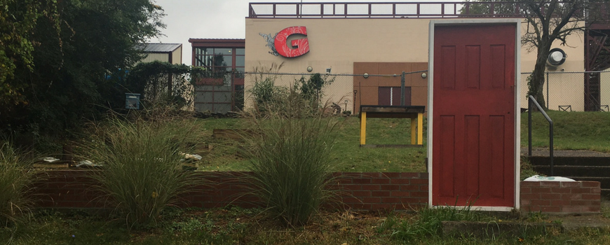
RED DOOR CIRCA 2016 (Photo credit: Grounded Strategies)

RED DOOR CIRCA 2022 (Photo credit: Naysan Mojgani)